News Scenarios
Peoples beliefs and religious views can cause disagreements. We sometimes see these disagreements covered in the news. Below are two examples of these.
You need to read the stories and try to think about the two different views that are expressed.

Task 1: Read the news story below.

Task 2:
Imagine that you are the Christian nurse who wants to wear a crucifix. Write a short message to send to the hospital manager explaining why you think this should be allowed.
Then imagine yourself as the hospital manager and write a reply to the nurse.

Task 3: Read the news story below. There are two different viewpoints.
Task 4: Imagine that you are one of the Muslim girls who wants to wear the hijab at school. Tweet about how you feel.
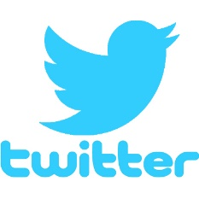

Write your tweet here. Remember to keep it under 120 characters

Now try writing a tweet response from the school.

Write your tweet here. Remember to keep it under 120 characters

